LAB#11

INTRODUCTION TO NEURAL NETWORKS

Implement Artificial Neural Network (ANN) and Convolutional Neural Network (CNN) using Python.

Neural Network
You’ve probably already been using neural networks on a daily basis. When you ask your mobile assistant to perform a search for you—say, Google or Siri or Amazon Web—or use a self-driving car, these are all neural network-driven. Computer games also use neural networks on the back end, as part of the game system and how it adjusts to the players, and so do map applications, in processing map images and helping you find the quickest way to get to your destination. A neural network is a system or hardware that is designed to operate like a human brain. Neural networks can perform the following tasks:
  - Translate text
  - Identify faces
  - Recognize speech
  - Read handwritten text
  - Control robots etc.

Artificial Neural Network (ANN)
Artificial Neural Networks are a special type of machine learning algorithms that are modeled after the human brain. That is, just like how the neurons in our nervous system are able to learn from the past data, similarly, the ANN is able to learn from the data and provide responses in the form of predictions or classifications. ANNs are nonlinear statistical models which display a complex relationship between the inputs and outputs to discover a new pattern. A variety of tasks such as image recognition, speech recognition, machine translation as well as medical diagnosis makes use of these artificial neural networks.
An important advantage of ANN is the fact that it learns from the example data sets. Most commonly usage of ANN is that of a random function approximation. With these types of tools, one can have a cost-effective method of arriving at the solutions that define the distribution. ANN is also capable of taking sample data rather than the entire dataset to provide the output result. With ANNs, one can enhance existing data analysis techniques owing to their advanced predictive capabilities.

ANN Architecture:
In order to understand the workings of ANNs, let us first understand how it is structured. In a neural network, there are three essential layers:

Input layer: The input layer is the first layer of an ANN that receives the input information in the form of various texts, numbers, audio files, image pixels, etc.
Hidden layer: In the middle of the ANN model are the hidden layers. There can be a single hidden layer, as in the case of a perceptron or multiple hidden layers. These hidden layers perform various types of mathematical computation on the input data and recognize the patterns that are part of.
Output layer: In the output layer, we obtain the result that we obtain through rigorous computations performed by the middle layer.
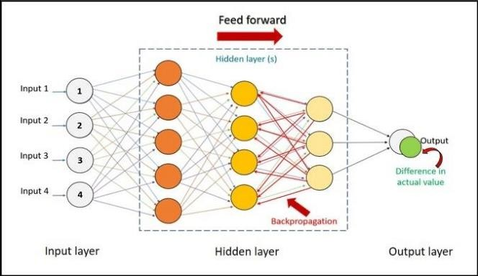
Figure 11.1 Artificial Neural Network Architecture

ANN Applications:
There are some important Artificial Neural Network applications such as:
  - Handwritten character recognition
  - Speech recognition
  - Signature classification
  - Facial recognition

Convolutional Neural Network (CNN)
A convolutional neural network is a feed-forward neural network that is generally used to analyze visual images by processing data with grid-like topology. It’s also known as a ConvNet. A convolutional neural network is used to detect and classify objects in an image.

(a) CNN Architecture:
A convolution neural network has multiple hidden layers that help in extracting information from an image. The four important layers in CNN are:
Convolution layer: This is the first step in the process of extracting valuable features from an image. A convolution layer has several filters that perform the convolution operation. Every image is considered as a matrix of pixel values.

ReLU layer: ReLU stands for the rectified linear unit. Once the feature maps are extracted, the next step is to move them to a ReLU layer. ReLU performs an element-wise operation and sets all the negative pixels to 0. It introduces non-linearity to the network, and the generated output is a rectified feature map.

Pooling layer: Pooling is a down-sampling operation that reduces the dimensionality of the feature map. The rectified feature map now goes through a pooling layer to generate a pooled feature map.

Fully connected layer: The next step in the process is called flattening. Flattening is used to convert all the resultant 2-Dimensional arrays from pooled feature maps into a single long continuous linear vector. The flattened matrix is fed as input to the fully connected layer to classify the image.
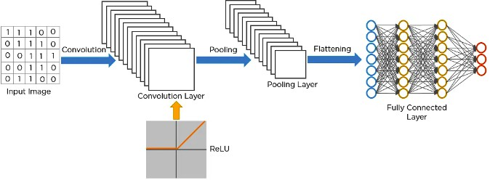
Figure 11.2 Convolutional Neural Network Architecture

Activity- 1:
The Modified National Institute of Standards and Technology (MNIST) database includes a dataset that contains approximately 60,000 training images and 10,000 testing images of handwritten digits. Implement Artificial Neural Network (ANN) to train neural network, and then use the test dataset to look at its accuracy. Finally, give your own handwritten digit to check the predictions by trained model.

Activity- 2:
Use Convolutional Neural Network (CNN) to do handwritten digits classification using MNIST dataset. We already use ANN for digit classification. You need to modify the code to use CNN. Check how accuracy improve fast by CNN and figure out how CNN can be a better choice for doing image classification compared to ANN. Shows the result by comparing Confusion Matrix and Classification report.

Activity- 3:
Implement Artificial Neural Network (ANN) on CIFAR10 dataset.

Activity- 4:
Implement Convolutional Neural Network (CNN) on CIFAR10 dataset.

